Name___________________________
Date____________________________
Period___________________________

South West Asia (Middle East) Ethnic Groups

ARABS
http://www.adc.org/2009/11/facts-about-arabs-and-the-arab-world/
- "_________" is a cultural and linguistic term. Most Arabs are __________ but there are also millions of __________ Arabs and thousands of _________ Arabs.
- The Arab World consists of 22 countries in the ________ ________ and __________ _______.
- There are an estimated _____________ Muslims in the world. The ten countries with the largest Muslim population are: Indonesia (170.3 million), __________ (136 million), Bangladesh (106 million), India (103 million), _________ (62.4 million), _______ (60.7 million), _________ (53.7 million), Nigeria (47.7 million) and China (37.1 million). Of these countries only ________ is an Arab country.
- A Muslim is a follower of ___________.
http://www.cotf.edu/earthinfo/meast/mepeo.html
- Arabs constitute the ___________ ethnic group in all of the Middle East states except _______, __________, and ___________.
- Originally, the term "Arab" referred to the peoples that inhabited the __________ and _________ portions of the ___________ ____________.
- The term "Arab" has come to be synonymous with those who speak ________. Presently, about ______ of the total population in the Middle East speak Arabic and consider themselves to be an _______.
https://en.wikipedia.org/wiki/Arab_world
- Shade in the countries that are members of the Arab World:
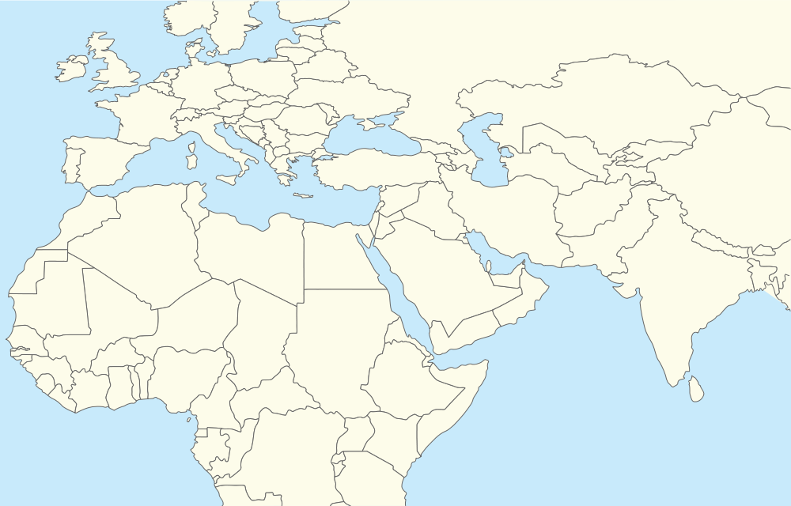
- The sentiment of Arab ___________ arose in the second half of the ______ century along with other nationalist movements within the __________ __________. The Arab League was formed in ________ to represent the interests of the Arabs, and especially to pursue the political unification of the Arab countries, a project known as _____________.
https://www.google.com/?gws_rd=ssl#q=nationalism+definition
- Define “nationalism” - ____________________________________________________________________________________________________________________________________________________________.

BEDOUINS
https://en.wikipedia.org/wiki/Bedouin
- The Bedouins are an Arab _______________ group, descended from ________ who have historically inhabited the ________ and _________ Deserts. Their name means "_______ __________" in Arabic. Their territory stretches from the vast deserts of _______ _________ to the rocky sands of the __________ _______. They are traditionally divided into _______, or _______ and share a common culture of _________ ________ and ________.
- While many Bedouins have abandoned their __________ and _______ traditions for modern _______ lifestyle, they retain traditional Bedouin culture with concepts of belonging to traditional ________, ________, ________, and many other _________ practices. Urbanized Bedouins also organize cultural ___________, usually held several times a year, in which they gather with other Bedouins to partake in, and learn about, various Bedouin ________ - from ________ recitation and traditional _______ _______, to classes teaching traditional ______ __________ and playing traditional Bedouin _________ __________. Traditions like _____ riding and _________ in the deserts are also popular leisure activities for urbanized Bedouins who live within close proximity to _________ or other wilderness areas.
- Livestock and _________, principally of _______ and dromedary _______ comprised the traditional livelihoods of Bedouins. These two animals were used for _______, ______ __________ and ________. Most of the staple foods that made up the Bedouins' ______ were ________ ___________.
- ______ _________ was the most popular art form among Bedouins. Having a poet in one's ________ was highly regarded in _________. In addition to serving as a form of ______, poetry was used as a means of conveying ___________ and ________ _________.
http://www.britannica.com/topic/Bedouin
- The Bedouin constitute only a ________ part of the total population of the ________ ______ but ________ or utilize a large part of the land area. Most of them are animal ________ who _________ into the _________ during the rainy _______ season and move back toward the cultivated land in the dry _________ months. Although the Bedouin, as a matter of caste, traditionally despise ___________ _______ and other _________ _______, many of them have become ____________ as a result of political and economic developments, especially since ________________.

http://andydesertx.blogspot.com/2012/05/sahara-desert-bedouin.html
- Shade in the areas where Bedouins live.

JEWS
https://www.jewishvirtuallibrary.org/jsource/Judaism/jewpop.html
- The top three countries where Jews live are: __________, ___________ _________, and _________.
https://en.wikipedia.org/wiki/Judaism
- Judaism, the distinctive characteristics of the Judean ethnos encompasses the ________, __________, ________ and way of life of the _________ people. Judaism is an ancient ______________ religion, with the _________ as its foundational text.
- Jews are an ____________ group and include those born ________ and converts to Judaism. In ________, the world Jewish population was estimated at about ____________, or roughly _____% of the total world population. About ______% of all Jews reside in _________ and another _______% reside in ___________________, with most of the remainder living in ________, and other minority groups spread throughout South America, Asia, _________, and Australia.
http://www.science.co.il/Israel-history.php
- The people of Israel (also called the "_______ _______") trace their origin to __________, who established the belief that there is only one _______, the creator of the ___________.
- The people of modern day Israel share the same _________ and _______ shaped by the Jewish ________ and _________ passed through generations starting with the founding father Abraham (ca. ______ BCE). Thus, Jews have had continuous presence in the land of Israel for the past _______ years.
- In _______, Jewish Community in Israel under the leadership of __________________ reestablished sovereignty over their ancient __________. Declaration of independence of the modern State of Israel was announced on the day that the last ________ forces left Israel (_______ ___, 1948).
- A day after the declaration of independence of the State of Israel, armies of ______ Arab countries, ________, _______, Transjordan, Lebanon and ________, invaded Israel.
http://www.history.com/topics/world-war-ii/the-holocaust
- What was the Holocaust? When did it happen? How many Jews were killed? ____________________________________________________________________________________________________________________________________________________________________________________________________________________________________________________________________________________________________________.

KURDS
http://www.cfr.org/middle-east-and-north-africa/time-kurds/p36547?gclid=CPOChZjy0ccCFQqQaQodRpoKfg#!/?cid=ppc-Google-grant-kurds_infoguide-072715
- The Kurds are one of the ___________ peoples of the Middle East and the region's ______-largest _______ group. They speak ________, an Indo-European language, and are predominantly ______ ________. Kurds have a distinct ________, traditional ______, and _________, including _________, the springtime New Year festival that is also celebrated by ___________ and others who use the ________ calendar. Kurdish __________ emerged during the ___________ century following the disintegration of the _________ Empire and the formation of new nation-states across the Middle East.
- The estimated ________ _________ Kurds reside primarily in ___________ regions of present-day _______, _______, _______, and ________ and remain one of the world's largest peoples __________ a sovereign state. The Kurds are not monolithic, however, and tribal identities and political interests often supersede a unifying _________ __________. Some Kurds, particularly those who have _________ to ______ centers, such as _________, ________, and ________, have integrated and _____________, while many who remain in their ancestral lands maintain a strong sense of a distinctly ________ identity. A Kurdish __________ of an estimated ______ ____________ is concentrated primarily in _____________.
- Kurds have a long history of ______________ and ____________, and, particularly in _______ and __________, have repeatedly risen up to seek greater autonomy or complete _____________.
- _______ countries are home to large Kurdish __________, who call the mostly contiguous area they inhabit ___________, or ______ of the Kurds. In two of these countries, Kurds have established different and separate forms of ____________.

- Shade in the areas where Kurds live:

https://en.wikipedia.org/wiki/Kurdistan
- Kurdistan or _________ _________ is a roughly defined geo-cultural region wherein the Kurdish people form a prominent ___________ population, and Kurdish ________, ________, and national ________ have ___________ been based. Kurdistan roughly encompasses the northwestern ________ and the eastern ________ mountain ranges.
- Sketch the Kurdistan flag:

PERSIANS
http://www.britannica.com/topic/Persian
- Persian, predominant _______ ______ of ______ (formerly known as _______). Although of diverse _________, the Persian people are united by their _______, Persian (______), which belongs to the ______________ group of the Indo-European language family. (_____, a variant of the Persian language, is the lingua franca and an official language of ____________ and is also spoken in ___________.)
- The name Persia derives from ________, the name of the Indo-European __________ people who migrated into ___________ ________—to an area then called _______—about ______ BCE.
- The vast majority of Persians practice ________ Islam. Before the ________ conquest of Persia in the _____ century CE, most Persians followed ________________, based on the teachings of the ancient __________ ____________.
- The traditional _______________ cloth and ________ industries have remained strong, despite competition from _______________ _________ _______. Persian villages often pride themselves on the unique _________ and high quality of their carpets, most of which display the typical ___________ figures and ________ designs prevalent in _________ visual art.
http://www.farsinet.com/farsi/
- Shade in the areas where Persians live:
