Name_____________________
Date______________________
Period____________________
ARABS
- Shade in where the Arabs are found:
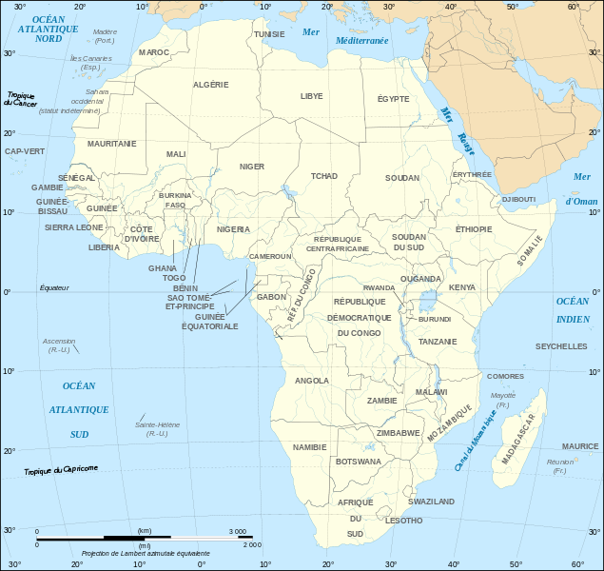
- Describe the religion(s) of Arabs:

- What is the language of the Arabs?

- What is a souq?
ASHANTI
- Shade in where the Ashanti are found::
- Describe the religion(s) of the Ashanti:

- What is the language of the Ashanti?

- What is the golden stool?

BANTU
- Shade in where the Bantu are found:
- Describe the religion(s) of the Bantu:

- What language do the Bantu speak?

- How many ethnic groups make up the Bantu?

- What are the traditional jobs of the Bantu?

SWAHILI
- Shade in where the Swahili are found:
- Describe the religion(s) of the Swahili:

- What is the language of the Swahili?

- What are the traditional jobs of the Swahili?

- Discuss the importance of amulets and spiritual healers:

