Getting to Know Africa: 50 Interesting Facts…
Posted by Steve Boyes of National Geographic Expeditions on October 31, 2013
(92)
More »
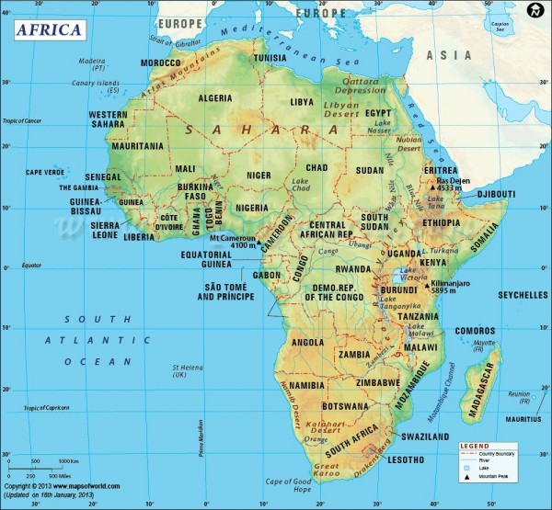

- There are 54 countries and one “non-self governing territory”, the Western Sahara, in Africa.
- All of Africa was colonized by foreign powers during the “scramble for Africa”, except Ethiopia and Liberia.
- Before colonial rule Africa comprised up to 10,000 different states and autonomous groups with distinct languages and customs.
- The Pharaonic civilization of ancient Egypt is one of the world’s oldest and longest-lasting civilizations.
- African continent is the world’s oldest populated area.
- Arabic is spoken by 170 million people on the continent, followed in popularity by English (130 million), Swahili (100), French (115), Berber (50), Hausa (50), Portuguese (20) and Spanish (10).
- Over 25% all languages are spoken only in Africa with over 2,000 recognised languages spoken on the continent.
- Africa is the second most populous continent with about 1.1 billion people or 16% of the world’s population. Over 50% of Africans are under the age of 25.
- The continent’s population will more than double to 2.3 billion people by 2050.
- Africa is the world’s poorest and most underdeveloped continent with a continental GDP that accounts for just 2.4% of global GDP.
- Almost 40% of adults in Africa are illiterate – two-thirds are women. Adult literacy rates are below 50% in Benin, Burkina Faso, Chad, Ethiopia, Guinea, Mali, Niger, Senegal, Sierra Leone and The Gambia.
- Over 25 million people are HIV-positive on the continent and over 17 million have died of the disease already.
- The Second Congo War claimed over 5.4 million lives and is the deadliest worldwide conflict since World War II.
- There are fewer people with internet connections in Africa than there are in just New York City.
- Approximately 90% of all cases of malaria worldwide occur in Africa, accounting for 24% of all child deaths in sub-Saharan Africa.

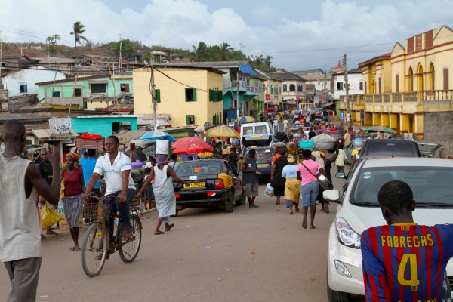A fishing village in Ghana is a bustle of activity as traders come and go… (Steve Boyes)

- Africa is the world’s second largest continent covering about over 30 million square kilometers
- The Sahara is the largest desert in the world and is bigger than the continental USA.
- Africa is the world’s hottest continent with deserts and drylands covering 60% of land surface area (e.g. Kalahari, Sahara and Namib).
- Africa is the world’s second driest continent (after Australia).
- Africa has approximately 30% of the earth’s remaining mineral resources.
- Nigeria is fourth largest oil exporter in the world, and Africa’s biggest oil producer with about 2.2 million barrels produced every day. Top 10 oil producers in order of total exports: Nigeria, Algeria, Angola, Libya, Egypt, Sudan, Equatorial Guinea, Republic of Congo, Gabon, South Africa.
- The continent has the largest reserves of precious metals with over 40% of the gold reserves, over 60% of the cobalt, and 90% of the platinum reserves.

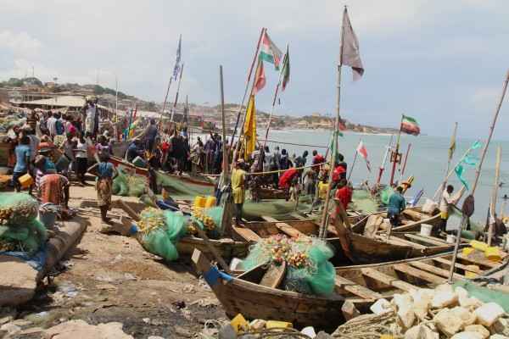Every year the catch gets smaller and smaller. For better luck the flags have been getting brighter and more abundant. Today the fish are small and few due to exploitation by commercial fishing vessels. (Steve Boyes)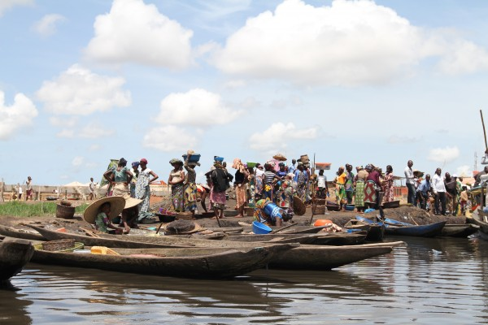Boat taxis and fishermen waiting to depart for Ganvi Village with passengers… (Steve Boyes)

- China is Africa’s top trade partner with Sino-African trade volumes now nearing $200 billion per year.
- China’s direct investment in Africa exceeds $50 billion. Just look at the “Forum on China Africa Cooperation”.
- Neocolonialism is a real threat with over 1 million Chinese citizens on the African continent. Angola alone has a population of over 350,000 Chinese.

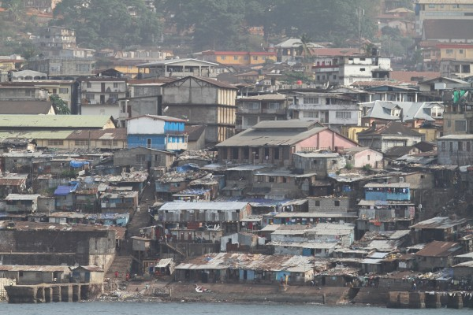Pigs walk around on top of 20m deep refuse piles at the water’s edge in Freetown (Sierra Leone). Most people do not use money and prefer to barter for sachets of clean water, the most valuable commodity in Freetown. (Steve Boyes)

- Over 55% of Africa’s labour force working in food production with vast areas of arable and pastoral lands supporting agricultural economies.
- Over 90% of soils are unsuitable for agriculture and only 0.25% has moderate to low potential for sustainable farming.
- Rainfall variability is very high – from 0 mm/year in the Sahara to 9,500 mm/year near Mount Cameroon.
- Over 240 million Africans suffer from chronic undernourishment.

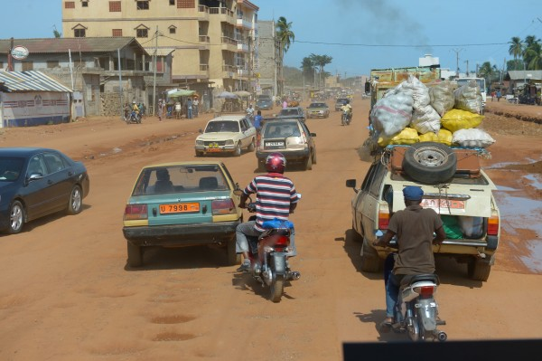The streets of Porto Novo, the capital of Benin, are not paved, all cars are second-hand, and all taxis are motorbikes. (Steve Boyes)

- Water scarcity impacts the lives of over 300 million Africans, of whom approximately 75% of Africans rely on groundwater as their primary source of drinking water. Global warming is aggravating the situation.
- Limited groundwater represents only 15% of the continent’s total renewable water resources. New discoveries of groundwater reserves in large sedimentary basins in Libya, Algeria and Chad may slack Africa’s growing thirst for the next few decades…
- Productivity of about 65% of the continent’s agricultural lands has declined significantly with vast tracts of land have been degraded by erosion, poor land management practices, mining and pollution over the last 50 years.
- Some landscapes are estimated to lose over 50 metric tonnes of soil per hectare per year due to neglect and desertification.
- Over 30% of Africa’s pastural land and almost 20% of all forests and woodlands are classified as moderately- or heavily-degraded.

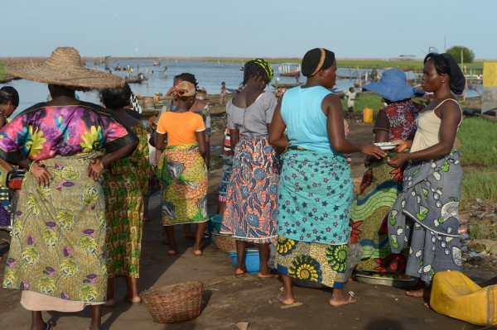Ladies waiting for a boat to take them back to the floating village of Ganvi in Benin. The water is polluted and the fish stocks are collapsing. Is there hope for communities like this? (Conrad Hennig)

- Deforestation rates in Africa are twice the average for the rest of the world with more than four million hectares of primary forest disappearing every year. Countries like Kenya, malawi and Zambia have 1-5% of the primary forests remaining. Forests used to cover over 20% of Africa’s 30 million square kilometers with almost all currently being destroyed and degraded by commercial and subsistence logging, as well as land conversion to plantations, agriculture, mines, roads and settlements.
- Some 60% of the tropical forests in the Congo Basin are considered commercially exploitable.
- Six of the top ten countries with the largest annual net loss of forested area are in Africa.
- Primary forests shrink by on average 40,000 square kilometres (or 0.6% of total remaining forest cover) each year with most significant losses in heavily-forested countries such as the Democratic Republic of Congo and Gabon.

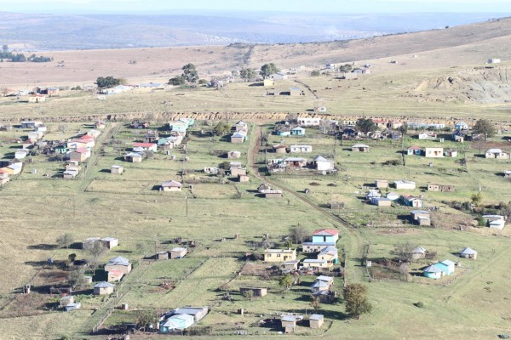Hala Village in the valleys below Hogsback Mountain where Cape parrots used to feed on yellowwood fruits, Celtis fruits, wild olives, and wild plums before they were chopped out by greedy colonists or burnt under communal land ownership. We have now planted thousands of indigenous fruit trees in “Cape Parrot Community Orchards” in several villages, fencing them off to protect them from livestock and paying local communities to care for them as the custodians of these forest plots. We have also launched a micro-nursery program that builds small tree nurseries for ten households in the village, which are stocked with yellowwood seedlings that must be grown up to planting size. These partnerships are all going from strength to strength. (Steve Boyes / Cape Parrot Project)

- Over 1,270 large dams have been built along the continent’s many rivers.
- Lake Victoria is the largest lake in Africa and the second-largest freshwater lake in the world.
- Africa has the most extensive biomass burning in the world, yet only emits about 4% of the world’s total carbon dioxide emissions.
- Africa has eight of the 11 major biomes and the largest-remaining populations of lion, elephant, rhinoceros, cheetah, hyena, leopard and hundreds of other species.

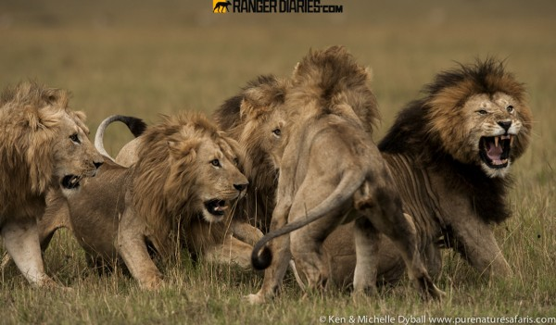Notch and sons, photographed by Ken Dyball. “We had the choice of going to a cheetah mother and four little cubs or sitting with five very lazy, sleeping male lions. We picked the lions…. and it looked like they would sleep until dark. A strong wind came up so they all got to their feet. One of the sons was a bit aggresive towards Notch (the father on the right). The other three sons were by Notch’s side wanting to join in at anytime! This was a time of testing each other out: a few of them had some recent and deep puncture wounds. Photographed in the Masai Mara, Kenya. (purenaturesafaris.com)

- Megafauna like giraffe, zebra, gorilla, hippopotamus, chimpanzee and wildebeest are unique to the continent and only found here.
- Lake Malawi has more fish species than any other freshwater system on earth.
- The Nile River is the longest river in the world with a total length of 6,650 kilometres.
- Africa has over 85% of the world’s elephants and over 99% of the remaining lions are on the African continent.
- Eight of Conservation International’s 34 biodiversity hotspots are in Africa.
- The Serengeti (Tanzania) hosts the world’s largest wildlife migration on Earth with over 750,000 zebra marching ahead of 1.2 million wildebeest as they cross this amazing landscape.
- Thera are over 3,000 protected areas in Africa, including 198 Marine Protected Areas, 50 Biosphere Reserves, 129 UNESCO World Heritage Sites, and 80 RAMSAR “Wetlands of International Importance”.
- Africa is home to the world’s largest living land animal, the African elephant, which can weigh up to 7 tons.
- Africa has over 25% of the world’s bird species.

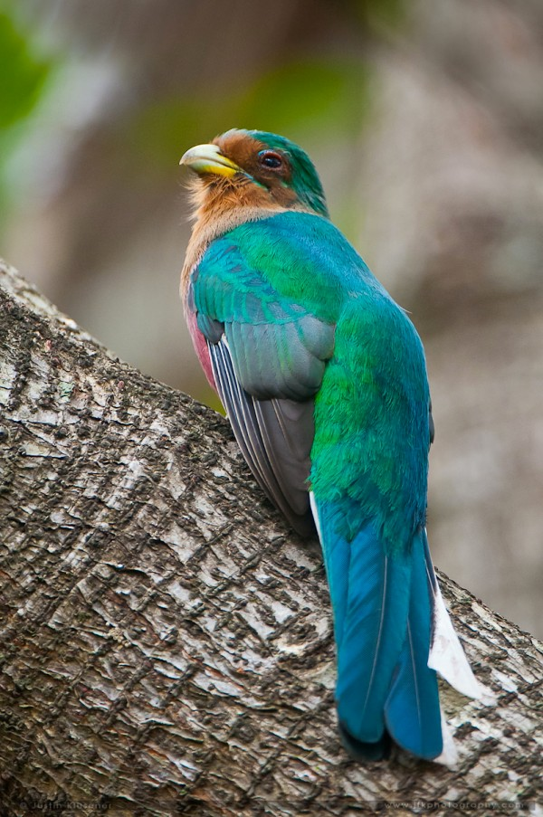
NarinaTrogons are the most widespread and generalist in their habitat preferences of the three Apaloderma trogons. Their name is “Khoikhoi” in origin and is believed to come from the mistress of the French ornithologist, François Le Vaillant. They are distributed from Sierra Leone to Ethiopia, and E Africa to South Africa. (Justin Klusener)

Today there are few truly wild places left on the continent with 1.1 billion people and a global economy looking to Africa for the resources to sustain development into the next century. Technology is going to help, but, if we carry on our current trajectory, we will destroy our greatest work. The colossal monument that now stands in Dakar (Senegal) was named “The African Renaissance”, and depicts a handsome couple holding their baby to the sky to beckon the dawning of an African century. In 2010, then-President Wade of Senegal said the following at the opening ceremony: “It brings to life our common destiny. Africa has arrived in the 21st century standing tall and more ready than ever to take its destiny into its hands”.
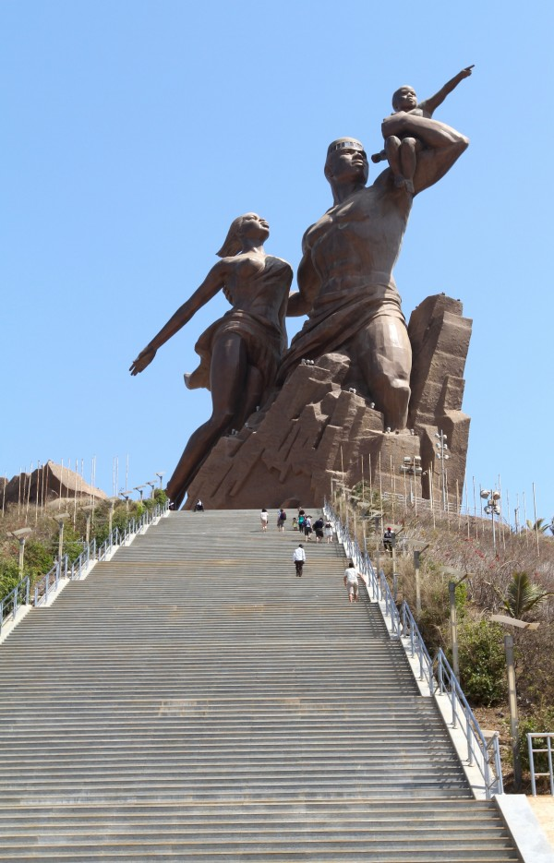
“African Renaissance” is located near the airport in Dakar (Senegal) and stands 49m tall on the top of a 100m high hill. It is the tallest statue in the world outside of Eurasia. (Steve Boyes)

